**PSG COLLEGE OF TECHNOLOGY, COIMBATORE – 641 004**

**Department of Applied Mathematics and Computational Sciences**

**M Sc SOFTWARE SYSTEMS – Semester IV**

**20XW48 – Web Designing Lab**

**PROBLEM SHEET 2 – HTML Tables, Image and Imagemap**

**Start Date: 3.1.2022 Complete Date: 13.1.2022**

1. Design a period table of the given form

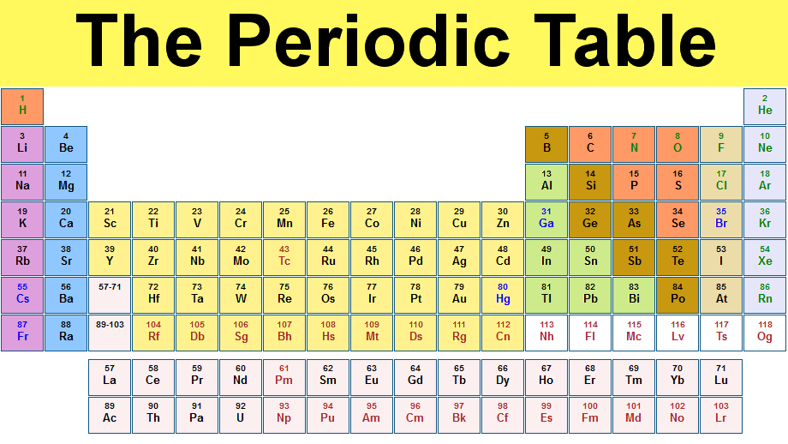

1. Design a table as given below. One image is align a left side and other image is in right sideas zigzap format. (Note: Instead of 1,2,3… you add any image and give description about an image)

(image type is animal/fruits/National leaders etc.,)



1. Design a table in the given way.

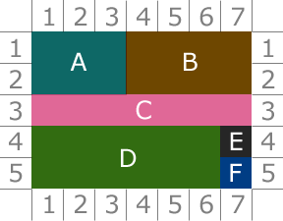

1. Design a table of ypur own with a background image. A sample is given for the reference.

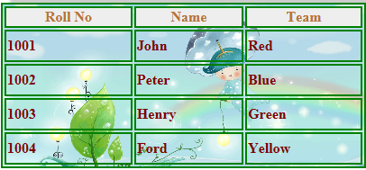

1. Design a page of the following design.

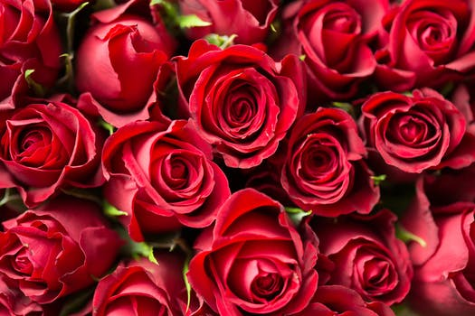

**Rose Flower** is a perennial plant the genus rosa, within the family roses. Roses are a popular crop for both domestic and commercial cut flowers. Generally they are harvested and cut when in bud, and held in refrigerated conditions until ready for display at their point of sale. In temperate climates, cut roses are often grown in greenhouses, and in warmer countries they may also be grown under cover in order to ensure that the **flowers** are not damaged by ~~weather~~ and that pests and disease control can be carried out effectively. There are many model project is on production of roses for use as cut flowers, which have an important place in *preparation* of bouquets, floral arrangements, worship, social occasions and presentation of gifts

1. **Image and Text**

The red chilipepperchilipepper is a popular food product in New Mexico.  What creates the heat in this pepper is the chemical *capsaicin* (C18H27NO3).  When eaten, natural endorphins in the body are released which not only reduce the pain from the heat but create a feeling of general well-being.

1. **Image and align text**

|  |  |
| --- | --- |
| **The Indian Flag** | |
| http://indianflag.facts.co/Indian_Flag_CC30_Pogaface.png | The National flag of India hasthreeequal horizontal bands - the top panel is India saffron (Kesari), the bottom panel is India green and white middle band bearing at its centre the design of Ashoka Chakra in navy blue colour with 24 equally spaced spokes. It was adopted by the Constituent Assembly on 22nd July 1947, when it became the official flag of the Dominion of India. The flag was subsequently retained as that of the Republic of India. The flag is based on the Swaraj flag, a flag of the Indian National Congress designed by PingaliVenkayya. |

1. Create a Html page which depicts the lifecycle of a chicken as shown.

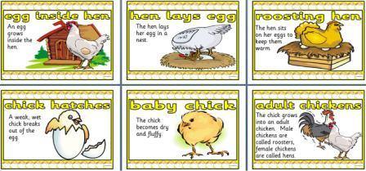

1. Create some links to various search engines (google, yahoo, etc).

[Search the web with Google!](http://www.google.com/)  
  
[Search the web with Yahoo!](http://www.yahoo.com/)  
  
[Search the web with Bing!](http://www.bing.com/)

1. Display five different images. Skip two lines between each image. Each image should have a title.
2. Display an image that has a border of size 2, a width of 200, and a height of 200.
3. Display an image that when clicked will link to a search engine of your choice (should be opened in a new window).
4. Create a webpage using image map tag. If click on any logo image, show the information about the company using unordered/ordered list tag. Minimum 5 information for each icon.



1. Design an image map for the given images. Info about indian states should be displayed when hover/clicked.

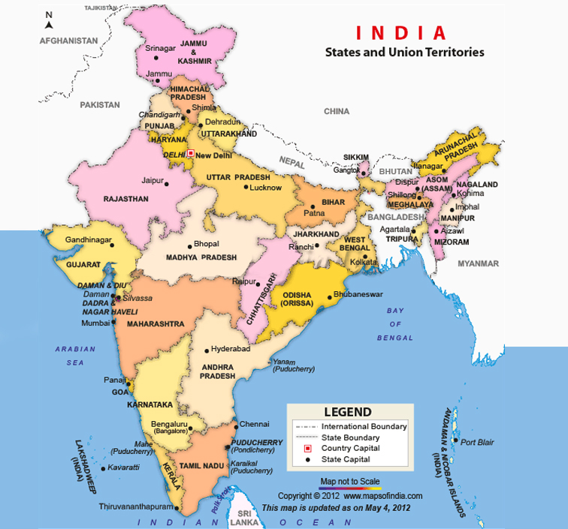

1. Design an image map for the given picture and when clicked/moved over, info about that person should be displayed.

